Newlands Medical Centre
April2022- March 2023
Patient Reference Group Annual Report
Cutajar Maria
PATIENTFOCUS GROUP REPORT FOR PERIOD APRIL 2022- MARCH 2023

NEWLANDS MEDICAL CENTRE
BOROUGH ROAD
MIDDLESBROUGH TS1 3RX

Group Profile

We value the opinions of all our patients and have been actively trying to recruit members onto our patient reference group, either virtual or physical.
We keep a register of patients on our virtual group to our contact lists and we now have an established, active group who are representative of all ages in the practice.

Our profile inApril 2022

Young - Aged less than 40 years
Single Parents
Ethnic Minority Group
Unemployed
Disabled
Retired patients
Patients in their teens
Patients with a Learning Disability

Patient Reference Group Distribution Report

PPG & Survey Results Report
The Patient group comprises 42members - current list size 10,185

1.3.2022/2023

Gender

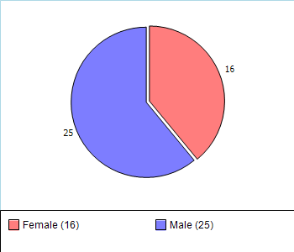

Ethnicity

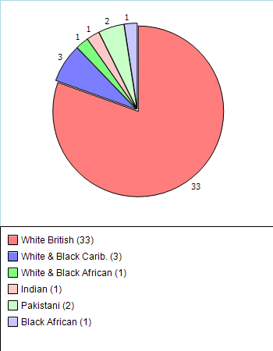

Age

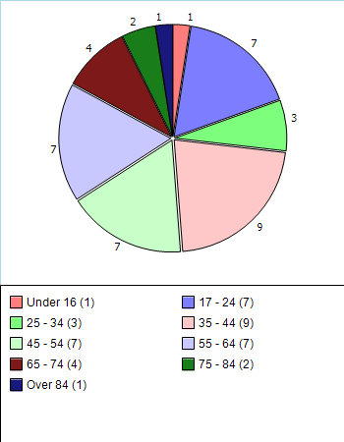

Attendance

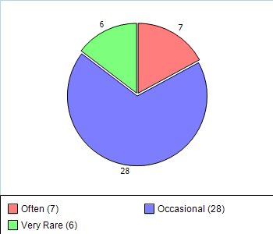

During the Covid -19 Pandemic – it was decided to still go-ahead with our Patient Focus Group meetings which we carried out through via zoom 2021-2022 / 22-23which was very successful and very productive. The PFG group set out 25 questions from 2022-2023 Patient satisfaction survey. It was agreed to carry these questions forward for the 2022/2023. In addition, the PFG was agreed to add two further questions to the survey around video consultation and econsult. We decided to give these out to the patients that attended and some over the telephone consultation.
- How do you rate our eConsult service?
- How do you rate our video consult service and Econsult?
These two questions have been added onto the questionnaire

Survey Methodology

Patients were given surveys in the waiting room and returned them to the practice.

Methodology was agreed at the PFG meeting in 2022
Patient survey was undertaken on paper by giving out surveys in the waiting room/ via the telephone
Group agreed the survey rate of 25 per GP/ Nurses/ HCA'a was adequate for 2022-2023

Questions Asked
Patient Satisfaction Survey 2022-2023

How are your requests handled by the reception team?
How quickly can you get an appointment with ANY
Doctor or Nurse?
How quickly can you get an appointment with the
Doctor of YOUR choice?
How quickly are you seen in relation to your
appointment time?
How easily can you get through on the phone normally
How easily can you get advice from the doctor or
Nurse on the phone?
How easily can you get a home visit if required?
How do you rate the available times of appointments?
(Currently 7.40am – 5.00pm?
how do you rate our texting reminder service
When you saw the doctor or nurse, how thoroughly
Did they listen to your symptoms?
When you saw the doctor or nurse, how well did
They put you at ease if you needed to be examined?
If you needed investigations in the Surgery (blood, ecg
Swabs), how quickly was this arranged?
If you needed a SECOND opinion or another
procedure by someone in the surgery, how quickly
Was this arranged?
If you needed referral to a specialist, how efficiently did
The secretary deal with your letter?
How well did the doctor or nurse explain the cause of
Your symptoms?
How well did the doctor or nurse deal with your worries
Or concerns?
How approachable was the doctor or nurse to discuss
Any problem you may have?
How involved did you feel in decisions about your care?
How well did the doctor or nurse deal with
Preventative care – keeping you healthy?
Were you offered a follow up appointment or told
When or why to return if necessary?
We are a training practice for junior doctors and medical
Students. How does this affect the quality
Of your care?
What do you feel about the range of services
Offered by the practice?
Overall, how do you rate the quality of care provided
By the practice?
How do you rate our eConsult service?
How do you rate our video consult service and Econsult?
These two questions have been added onto the questionnaire

Results 2022-2023

- 96.5% Patients felt as they still could still access a clinician even through the pandemic and coming out of the pandemic
- 95.2% of patients rated Econsults.
- 102% of patients felt that the surgery offered a good range of clinics by the practice.
- 95%of patients felt they were very involved in the decisions in their care
- 44% satisfactory of patients felt it was easy access to get through on the telephone 4% poor couldn’t get through
- 68% said they felt you could get a second opinion referral to secondary care

Action Plan 22023

Throughout our PFG meetings during 2022-23 It was agreed that our actions plan for 2023as follows

- Questionaries to be given out to some face 2 face and telephone consultation calls

- PFG are happy to set the questions from last year. With 2 additional around videos.

- A message on the telephone system promoting our email address for repeat prescriptions which we implemented back in September 2020 has really improved this service.

- Continue telephone consultations as patients find this very useful and it reduces the footfall into the practice to pre pandemic levels

- Results Keep the TV media current and up to date for patients in the waiting areanow we are resuming services.

- Staff will continue Promote health to patients for influenza / shingles/childhood immunisation / cervical screening /pneumonia

- If face to face appointments are not used on the day, we will revert them back into telephone consultations.

- We have a new telephone system now which was installed back in November 2021, and it gives management an overview of how many patients are in a queue and if they are a back log of calls management can see the telephone queueboard and we can adjust the staffing level to accommodate and reduce the above. In addition, thenew telephonesystem allows patients patient to receive a call back if they wish to.

- Promote online eConsults to patients for any admin queries and any skin conditions that may require photographic view.

- Doctors are seeing more face-to-faceappointments. We continue to increase face to face appointments and we have increased patient contacts to higher than pre pandemic levels

- We have opened our online services for nurses/ HCA's appointments in May 2022

- We have been allocated appointments for extended hours which we can offer patients from HCA's / Nurses / Advance Practitioners/ / GP's These are offered on an evening and Saturdays.

- We have a first contact practitioner inhouse and he is a skilled physiotherapist who can treat patients with musculoskeletal problems/ ongoing issues, if any patients have any problems with joints etc they can see a FCP. He can order scans. , Xray and prescribe as well as issuing sick notes.

- We can also refer patients to our local pharmacy to treat minor illness once the surgery has completed the referral the pharmacist will contact you within two hours with an appointment.

"You have asked, we have listened to you "
From our Patient Survey
Introduction of video and texts has been successful and will continue

Continue with Econsults

New phone system has improved the service response to getting through on the phone, call back service and queuing system so we can monitor calls
Promote TV and Media

www.newlandsmedical.org.uk

Practice Opening Hours

Monday- Friday 7.30am – 5.45 The Premises are open
Saturday, Sunday, and Bank Holidays are Closed.

Extended hours are opened by doctors, Advanced Clinical practitioners /Primary Care clinics
nurses and HCA Monday to Friday 7.30am until 8.00am Saturday and Sunday and bank holidays

Monday – Friday 8.00am – 6.00pm Telephone contact is available

